**Apple Inc.**

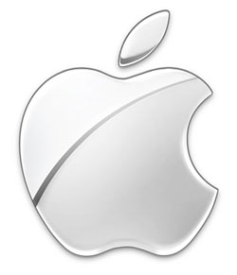

***Think Different !***

**Subject : Company Profile.**

**Company Name : Apple Inc.**

**Associate Professor : Prof. Churchill Samson.**

**Presented By : Yadnyawalkya Tale.**

**APPLE Inc. **

**ABSTRACT:**

Over the past 30 year, Apple has amplified from computer design to developing consumer electronics*. Tim Cook*,CEO of Apple is doing excellent job to running company. Apple uses a differential business strategy, which mean that all employees and department work together in the creation of their product, since employee work together our products tends to be more productive. Apples main business initiative is customer relationship management. When working with or purchasing from Apple you are promised top-notch customer service and assistance.

**INTRODUCTION:**

Apple Inc. is an American multinational corporation headquartered in Cupertino, California, that designs, develops, and sells consumer electronics, computer software, online services, and personal computers. Its best-known hardware products are the Mac line of computers, the iPod media player, the iPhone smartphone, and the iPad tablet computer. Its online services include iCloud, iTunes Store, andApp Store. Apple's consumer software includes the OS X and iOS operating systems, the iTunesmedia browser, the Safari web browser, and the iLife and iWork creativity and productivity suites.

**Industry Type :** Computer hardware and software, Consumer electronics

**Founded in :** April 1, 1976.

**Founded by :** Steve Jobs, Steve Wozniak , Ronald Wayne.

**Headquarters at :** Cupertino, California (CA, USA)

**Area served :** Worldwide

**Current CEO :** Tim Cook

**Boards Chairman :** Arthur D. Levinson (CEO of Oracle)

**Net Revenue :** US$ 358.98 billion [August, 2014]

**Employees :** 98,000 (2014) were [32,300 are Indian Employees]

**VISION :**

“ Man is creator of change in this world. As such he should be above system and structure and not subordinate to them.”

**MISSION :**

Apple committed to bringing the best personal computing experience to students , educator , creative professional and consumers around the world through its innovative software's,hardware’s and internet offering .

**HISTROY :**

* Apple was founded by *Steve Jobs*, *Steve Wozniak*, and *Ronald Wayne* on April 1, 1976, to develop and sell *personal computer kit* name Apple*-I*.
* In 1980, Apple’s IPO went to largest after breaking Ford Motor Company in stock market.
* In 1985, *John Sculley*, CEO of *PEPSICO* Became next CEO of *Apple*.
* In 1993, *Sculley* was replaced as CEO by *Michael Spindler*.
* In 1996, *Spindler* was replaced as CEO by *Gil Amelio*.
* In July 1997, *Jobs* return in company and acted as the *interim CEO* [iCEO] and began restructuring the company's product line.
* Due to health*,Jobs* was replaced by *Tim Cook* an he became *Apple's chairman.*
* And since death of *Steve Jobs in October 2011 , Tim Cook* working as *CEO of* Apple Inc.(until Now)

**APPLE’S PRODUCTS :**

iPod, iPhones, iPads, iTvs, iTunes, MacBook Pro, MacBook Air, iMac etc

**MANAGEMENT :**

* **Founders :** Steve Jobs, Steve Wozniak , Ronald Wayne.
* **Current C E O :**  Tim Cook
* **Director on Board :**  Arthur D. Levinson
* **Deputy President :**  Angela Ahrendts (Online stores)
* **Deputy President :**  Jonathan Ive (Design)
* **Deputy President :** Craig Federighi (Software Engineering )
* **Total Locations :** 427 retail Stores in 17 Countries (August 2014)

**ACHIEVEMENTS AND CURRENT POSITION :**

* World's second-largest information technology company by revenue after Samsung Electronics.

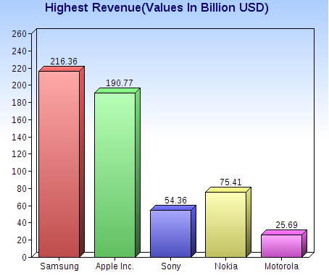

* World’s third-largest mobile phone maker after Samsung and Nokia.

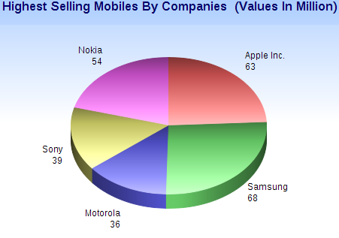

**CONCLUSION :**

Apple Inc. have more employment capability and flexibility than any other Electronics Consumer Company. And apple giving chance to served Human Mankind with help of Current advanced technology to all Employees.

**REFERENCES :**

**Links :**

1. http//www.apple.com/about/apple 2. http//www.wikipedia.com/applecomputer

**Others :**

Britannica Encyclopedia

Steve Jobs : By Walter Isaacson (Book)